DATE: 26.08.2025

EXPERIMENT – 11 Change Hardware compatibility of a VM (Either by clone/create new one) which is already created and configured, using virtual box.

**Aim:**

To change the hardware configuration of an already created and configured Virtual Machine using VirtualBox.

**Procedure:**

1. Open **Oracle VirtualBox** on your host machine.
2. Select the **virtual machine (VM)** whose hardware you want to modify.
3. Ensure the VM is **powered off**.
4. Right-click the VM and select **Settings**.
5. Navigate to the following hardware sections and modify as needed:
   * **System → Motherboard:** Change base memory (RAM), boot order.
   * **System → Processor:** Change the number of CPU cores.
   * **Display → Screen:** Adjust video memory or enable 3D acceleration.
   * **Storage → Controller:** Add or remove virtual hard disks.
   * **Network:** Change adapter type or network mode (NAT/Bridged).
6. Click **OK** to save the new configuration.
7. Start the VM and verify that it runs correctly with the updated hardware settings.

Output:

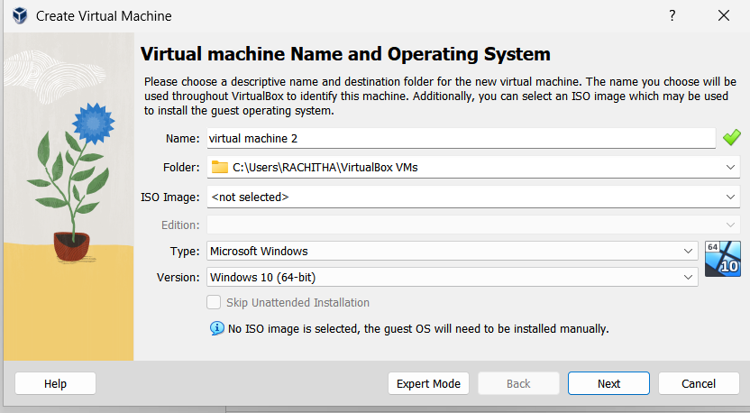

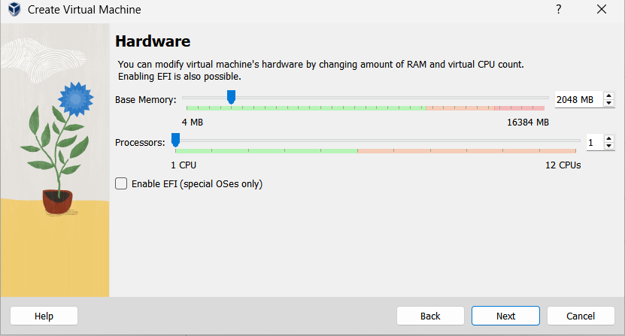

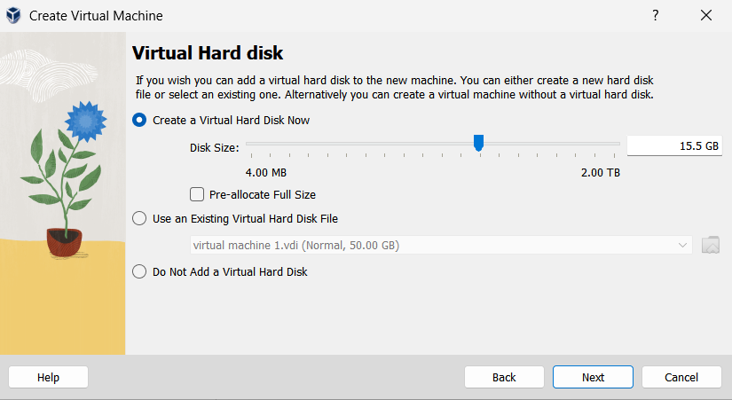

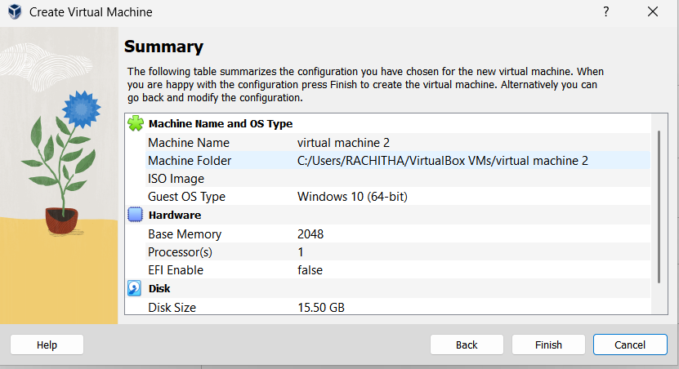

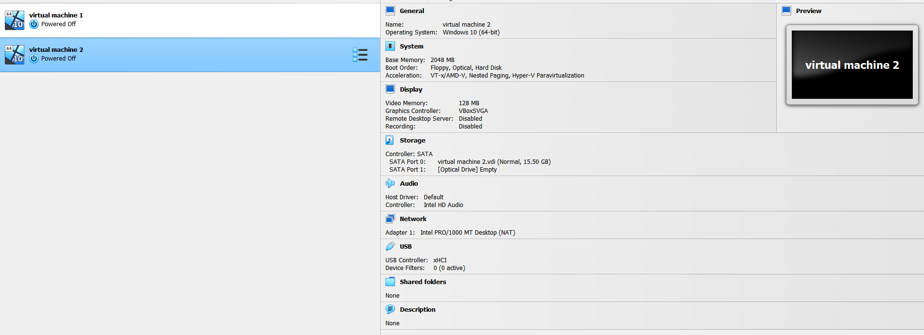

Result:

The hardware compatibility of the VM was successfully modified in VirtualBox. The VM ran correctly after changing RAM, CPU, storage, and other hardware settings, demonstrating hardware reconfiguration in a Type-2 Hypervisor.